PART 5: TRAVEL & HEALTH
CONTENTS
Transportation
Health & Immunization Info
Packing List

Transportation
ALL flights will be booked by the Project Transportation Coordinator – Donna Kushner, in cooperation with our amazing travel agent. YOU DO NOT NEED TO ARRANGE ANY FLIGHTS! She will be booking the flights and consulting with parents. More specific information will be coming to you and your student soon.

Health & Immunization Info

READ THE FOLLOWING CAREFULLY AND COMPLETELY!

This is a summary of numerous travel health related websites. Visit these to answer any health questions you have about Albania and Thailand

CDC- Center for Disease Control and prevention:
https://wwwnc.cdc.gov/travel/destinations/traveler/none/albania (ALBANIA)
https://wwwnc.cdc.gov/travel/destinations/traveler/none/thailand (THAILAND)

Be sure your routine vaccinations are up-to-date. Routine vaccines, as they are often called, such as those for influenza, chickenpox (or varicella), polio, measles/mumps/rubella (MMR), and diphtheria/pertussis/tetanus (DPT) are given at all stages of life.

IMPORTANT: Please bring a photocopy of your updated health record with you on the project.

Summary of recommendations from MD Travel Health Website:
All travelers should visit either their personal physician or a travel health clinic 4-8 weeks before departure.
The following are the recommended vaccinations for Albania and Thailand:
Hepatitis A vaccine is recommended for all travelers over one year of age. It should be given at least two weeks (preferably four weeks or more) before departure. A booster should be given 6-12 months later to confer long-term immunity.

Typhoid vaccine is recommended for all travelers. It is generally given in an oral form (Vivotif Berna) consisting of four capsules taken on alternate days until completed. The capsules should be kept refrigerated and taken with cool liquid. Ask your doctor if he/she recommends this.

Hepatitis B vaccine is recommended for all travelers if not previously vaccinated. Two vaccines are currently licensed in the United States: Recombivax HB (Merck and Co., Inc.) (PDF) and Engerix-B (GlaxoSmithKline) (PDF). A full series consists of three intramuscular doses given at 0, 1 and 6 months. Engerix-B is also approved for administration at 0, 1, 2, and 12 months, which may be appropriate for travelers departing in less than 6 months. Side-effects are generally mild and may include discomfort at the injection site and low-grade fever. Severe allergic reactions (anaphylaxis) occur rarely.
Tetanus-diphtheria vaccine is recommended for all travelers who have not received a tetanus-diphtheria immunization within the last 10 years.

Measles-mumps-rubella vaccine: two doses are recommended (if not previously given) for all travelers born after 1956, unless blood tests show immunity.

Yellow Fever - There is no risk of yellow fever in Albania & Thailand. The government of Albania & Thailand requires proof of yellow fever vaccination only if you are arriving from a country with risk of yellow fever. This does not include the US. If you are traveling from a country other than the US, check this list to see if you may be required to get the yellow fever vaccine.

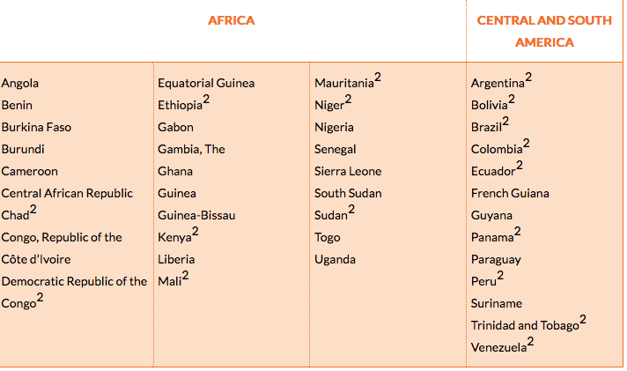

Summary of Vaccinations:
Hepatitis A | Recommended for all travelers
Typhoid | Recommended for all travelers
Hepatitis B | Recommended for all travelers
Measles, mumps, rubella (MMR) | Two doses recommended for all travelers born after 1956, if not previously given
Tetanus-diphtheria | Revaccination recommended every 10 years

Medications
Travelers' diarrhea is the most common travel-related ailment. The cornerstone of prevention is food and water precautions, as outlined below. All travelers should bring along an antibiotic and an antidiarrheal drug to be started promptly if significant diarrhea occurs. Most cases of traveler's' diarrhea are mild and do not require either antibiotics or antidiarrheal drugs. Adequate fluid intake is essential. If it is not simple to get an antibiotic dose don’t stress over this, we have easy access to medical care in Albania and Thailand.

Swimming and bathing precautions
Avoid swimming, wading, or rafting in bodies of freshwater, such as lakes, ponds, streams, or rivers. Do not use fresh water for bathing or showering unless it has been heated to 150 degrees F for at least five minutes or held in a storage tank for at least three days.

General advice
Bring adequate supplies of all medications in their original containers, clearly labeled. Carry a signed, dated letter from the primary physician describing all medical conditions and listing all medications, including generic names. If carrying syringes or needles, be sure to carry a physician's letter documenting their medical necessity. Pack all medications in hand luggage. Carry a duplicate supply in the checked luggage. If you wear glasses or contacts, bring an extra pair. If you have significant allergies or chronic medical problems, wear a medical alert bracelet.
Pack a personal medical kit, customized for your trip (see description). Take appropriate measures to prevent motion sickness and jet lag, discussed elsewhere.

Pharmacies
Most pharmacies are well-supplied. Most prescription medicines available in the United States are also available in Albania and Thailand, though sometimes under a different name.

Packing
Once you have your itinerary, check the flight regulations for carry-on luggage for every airline that you are flying with to and from country. Some may have lower weight maximums, or only allow one carry-on instead of two.

Guidelines: Pack appropriately!
Everyone is limited to one 50 lb bag (preferably one that rolls and is easy for you to manage on your own)
If you’re coming from Orlando, you may be asked to check an additional bag of resources and materials we need for the trip (we thank you ahead of time for your help)
You may bring mp3 players/ipods or other forms of personal entertainment for the plane (but not after that).
Students will not be able to use cell phones or any other device that gets internet on project. Internet will be provided on a weekly basis. Therefore bring a camera and some sort of alarm clock/watch with an alarm clock in it.

Suggested Items:
Baby Wipes (to keep you fresh and clean between showering opportunities)
Antibacterial Gel (a small container)
European Outlet Converter (for anything that will need charging)
Dual Watt electronics (basically anything that gets plugged in needs to be able to switch to a 220 current)
Plug Adapter for Europe
Camera
Protein Bars and other snacks (especially if you’re a picky eater)
Dramamine (for the plane if you get air sick or have a hard time sleeping)
Toilet Paper, 1 roll or tissue packets (might not always be readily available)
Ear Plugs (if you’re a light sleeper)
Travel Clock (since you will not have your phone to keep time)
Extra contact lenses if you wear them

Required Items:
Travel Bible
Pen and Journal
Email addresses of supporters to keep them updated (saved in an email is best)
Personal First Aid Kit (band aids, pepto bismol, antihistamines (you never know what you may be allergic to over there), Advil, calamine lotion, Benadryl, etc)
Bug Spray (ESPECIALLY FOR THAILAND)
Sunscreen
Wrist Watch (you won’t have your phone to check the time)
Reusable Water Bottle (important for staying hydrated)

Clothes to Pack:
It will not be acceptable for us to look sloppy. We will be representatives of the ministry and must therefore look put together and professional when doing ministry on campus and with students.

However, looking nice does not mean that you need to have a different outfit for every day of the trip or for every day of the week. Most Thai and Albanian people repeat their clothing often, and so we will be doing the same. So one and a half week’s worth of clothing will be all that we ask you bring. When in doubt about if something is appropriate, err on the side of modesty. Serving in a ministry context usually means being more careful about how much of our skin is showing.

Guys Clothing:
5 nice shirts (polos or button ups)
5 T-shirts (solid or with a logo/design that is appropriate
1 pair of khakis
2-3 pair of jeans
2 pair of shorts for tourist days or sleeping or maybe soccer that can get wet and dry quickly
Socks & undershirts
Modest sleepwear or sweats for sleeping
Athletic shoes (for our touring days, physical activity)
1 pair nicer shoes for campus and church
Sturdy sandals (not flip-flops) [OPTIONAL]
6 boxers or briefs
One modest bathing suit (no speedos or speedo briefs/shorts)
All the toiletries that you will need for the entire trip, do not expect to buy refills
A lightweight jacket for the evenings and days that get cool
Sweatshirt or something WARM for travel
Rainwear: waterproof jacket and small umbrella

Girls Clothing:
1-2 nice pants or Capris (not tight)
1-2 skirts or dresses, modest, touching knee
7 Tops (these can be button up, or basic tees but they need to look nice and professional, modest and no cleavage showing please)
3 T-Shirts (that can get dirty or for you to lounge in)
2 pair of shorts (ones that can get wet or dirty and easily dry and clean)
2 pairs of jeans (not tight)
Nice sandals (meaning not flip flops) that are comfortable to walk long distances in. [OPTIONAL-can wear shoes all the time if you want to]
Athletic Shoes (for our touring days, physical activity)
All the toiletries that you will need for the entire trip, do not expect to buy refills
Travel Hair Dryers (need to be able to use the 220 currency and have adaptor)
NO FLAT IRONS unless you’re able to find dual currency irons
Anything else you’ll need to keep your hair looking nice, there will be no hiding your hair under a bandana
Underwear for a week
Sports Bra
Socks for athletic shoes
One modest [one piece or tankini] bathing suit and cover up
Modest sleepwear or sweats for sleeping
A lightweight jacket for the evenings and days that get cool
Sweatshirt or something WARM for travel
Rainwear: waterproof jacket and small umbrella

Pa

